TOTHBOT — KRAKEN SYSTEM ARCHITECTURE OVERVIEW
The Complete System — All Architectural Decisions + All Flow Diagrams

DocDCN: 0500000
DocTitle: TothBot_Kraken_System_Architecture_Overview
DocVersion: dv1_10
DocOwner: Bill
DocPath: GitHub.com/TothBot/TothBot-V2-Docs/05XXXXX_System_Architecture/0500000_System_Architecture_Overview_dv1_10.docx
DocDate: 03-25-2026
DocTime: 23:59:59 UTC

PURPOSE: This document captures all architectural decisions, FP/DP analyses, and system specifications from the TothBot Kraken architecture sessions of March 2026. Includes all six system flow diagrams showing connections between Kraken, TothBot, and CIATS as one unified organism.

Diagrams: dv1_10 — Diagrams 1 and 6 updated.
Diagram 1 — Kraken API Connection Architecture (dv1_10: GAP-B stp_type correction, A-21 deadline, IMP-16/17 aiohttp, IMP-18 bbo, IMP-19 regime stagger)
Diagram 2 — TothBot Trading Pipeline
Diagram 3 — Exit Architecture: Ground Zero Redesign
Diagram 4 — Regime Taxonomy: 6-Regime Grid + Two-Level Tagging
Diagram 5 — CIATS Architecture: Data Flows and Improvement Cycle
Diagram 6 — Complete System: One CIATS-Owned Organism (dv1_10 updated)

1. System Identity and Mission

1.1 What TothBot Is
TothBot is an automated cryptocurrency spot trading system on Kraken exchange. It runs 24/7/365 on a Hetzner VPS, processes 5-minute OHLC candle close events as its system clock, and executes long-only trades using a momentum-based signal engine.

TothBot is not an external system connected to Kraken — it IS Kraken's event processor. Every action is a response to a Kraken push event. No timers. No polling. Idle and silent until Kraken speaks.

1.2 The One Organism Principle
Three functional zones, one organism:
Kraken: generates events, executes orders, holds resting TP limit orders and
off-book emergency SL stop orders on matching engine
TothBot: processes Kraken events, executes trading strategy, manages positions
CIATS: learns from event records, continuously improves processing rules

PRIMARY MISSION: Maximize profit. Minimize loss. With an emphasis on minimizing loss. Loss prevention takes priority over profit generation. Everything else is secondary.

1.3 Operating Environment
Exchange: Kraken Spot (Long Module — Short deferred)
Language: Python 3.12.3
VPS: Hetzner CPX22 — 87.99.141.44 — Ashburn VA
(Evaluate migration to Hillsboro OR — AWS us-west-2 adjacent)
System Clock: Kraken OHLC 5-minute candle close event (WS v2 push)
Fee Baseline: Maker 0.16% / Taker 0.26%
Starting Portfolio: $1,000 Long Module
Sacred constraint: Net 1:1.5 R:R — HARDCODED — the only number not owned by CIATS

2. Kraken API Connection Architecture
All connection points verified across 3 independent analysis passes (15 sources) plus 2 deep validation sessions (144+ sources) plus 3 sequential 10-search FP/DP Kraken validation sessions [dv1_6, dv1_9, dv1_10] (316+ sources total).

Diagram 1 — Kraken API Connection Architecture (dv1_10)
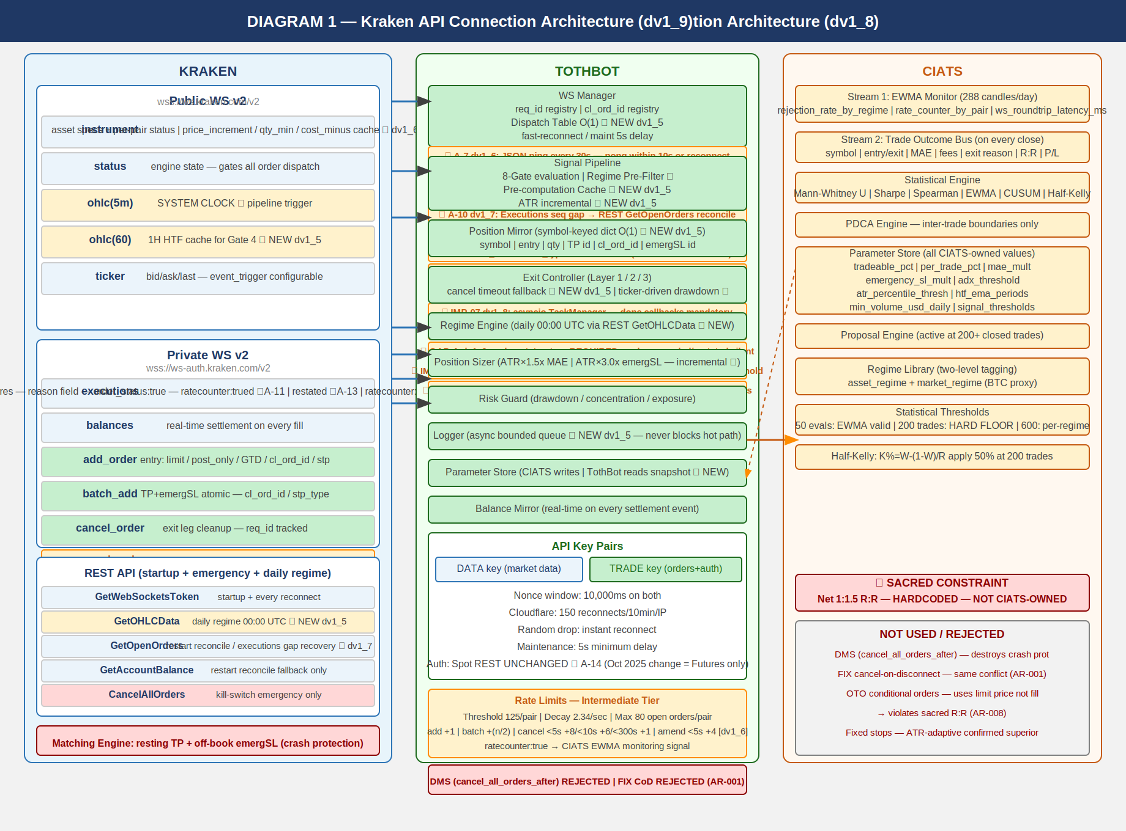

2.1 Key Connection Points
Public WS v2 (wss://ws.kraken.com/v2):
instrument — PairSpec cache: price_increment, qty_min, cost_min, status ★ GAP-C/D
status — engine state (online/post_only/cancel_only/maintenance)
ohlc(5m) — SYSTEM CLOCK (pipeline trigger; fires on trades, not wall clock)
ohlc(60) — 1H HTF cache for Gate 4; parse interval_begin ★ GAP-B dv1_9
ticker — event_trigger:bbo (open positions) / trades (no position) ★ A-23 dv1_10

Private WS v2 (wss://ws-auth.kraken.com/v2):
executions — fills/expires/amends/restated; order_status:true MANDATORY ★ GAP-A
snap_orders:true, snap_trades:true, ratecounter:true
sequence gap detection ★ A-10; parse reason not cancel_reason ★ A-11
balances — real-time settlement; sequence gap detection ★ A-9
add_order — limit/post_only/GTD/cl_ord_id/stp_type:cancel_newest/deadline:now+5s ★ A-20/A-21
amend_order — PRIMARY amendment method (edit_order DEPRECATED) ★ dv1_6
batch_add — TP+emergSL atomic on fill; cl_ord_id/stp_type:cancel_newest/deadline:now+5s
cancel_order — exit leg cleanup; req_id tracked
batch_cancel — Full Halt multi-order cancel ★ dv1_6

REST (startup + emergency + daily):
GetWebSocketsToken — startup + every reconnect
GetOHLCData — daily regime at 00:00 UTC; CRITICAL: exclude response[-1]
STAGGER 1.1s/pair to avoid rate limits ★ A-24 dv1_10
GetOpenOrders — restart reconcile + executions gap recovery ★ dv1_7
GetAccountBalance — restart reconcile + balances gap recovery
QueryOrdersInfo — targeted order reconciliation on restated events ★ IMP-15
CancelAllOrders — kill switch emergency only
All REST via aiohttp; ClientTimeout(total=10,connect=5,sock_read=8) ★ A-22 dv1_10
TCPConnector(limit=10,limit_per_host=5,force_close=False) ★ A-22 dv1_10

Matching Engine (always active — crash protection):
Resting TP limit orders — survive any TothBot failure
Off-book emergSL stop-market orders — survive any TothBot failure
DMS and FIX cancel-on-disconnect REJECTED — both destroy crash protection (AR-001)

2.2 Four Kraken Engine States
online — All orders. Signal pipeline runs normally.
post_only — TothBot limit+post_only entries valid. Trading continues.
cancel_only — No new entries. Exit Controller can cancel. Resting orders active.
maintenance — No orders, no cancels. Resting TP and emergSL active on engine.

2.3 API Rate Limits — Intermediate Tier
Rate limits shared across REST, WebSockets, and FIX — no separate per-protocol budget.
Rate counter threshold (per pair): maxratecount from executions ACK ★ IMP-11
(starting value 125 — do not hardcode)
Rate counter decay (per second): 2.34
Max open orders (per pair): 80
add_order fixed cost: +1
amend_order (PRIMARY, +1 fixed): +3(<5s), +2(<10s), +1(<15s)
edit_order DEPRECATED — DO NOT USE: +6(<5s), +5(<10s)
batch_add fixed cost: +(n/2)
cancel_order cost (<5s old): +8
cancel_order cost (<10s old): +6
cancel_order cost (<300s old): +1
batch_cancel: cumulative sum of individual cancel costs

2.4 WS Operational Requirements (A-1 through A-24)
A-1 Rate counter monitoring via executions channel (ratecounter:true at zero additional cost). CIATS EWMA adds rate_counter_by_pair as third monitoring signal.
A-2 req_id and cl_ord_id on all outbound WS messages. Position Mirror records cl_ord_id at dispatch — no async gap.
A-3 Round-trip latency monitoring: time_in/time_out on all responses. CIATS EWMA adds ws_roundtrip_latency_ms.
A-4 stp_type:cancel_newest on all WS v2 add_order and batch_add. WS v2 uses UNDERSCORES. REST uses hyphens. Do not confuse. (AR-032)
A-5 Reconnect behavior: (1) random drop — instant reconnect up to 5 attempts. (2) maintenance confirmed — minimum 5s delay. Exponential backoff after attempt 5 (1s initial, 2x, 30s cap, +10% jitter).
A-6 OTO conditional orders REJECTED: uses limit price not fill price, violates R:R, Position Mirror race condition.
A-7 WS Ping: JSON ping every 30s. Pong within 10s or dead connection. Reconnect immediately.
A-8 Zombie detection: last_real_data_time per connection. Elapsed >90s = ZOMBIE_CONNECTION. Alert + reconnect.
A-9 Balances sequence gap detection. Any skip = missed ledger. Alert + REST GetAccountBalance reconcile.
A-10 Executions sequence gap detection. Any skip = missed fill/cancel. CRITICAL severity. Alert + REST GetOpenOrders.
A-11 cancel_reason DEPRECATED (Dec 2023). Parse reason field only. Silent None on cancel_reason.
A-12 Complete exec_type dispatch: pending_new, new, trade, filled, iceberg_refill, canceled, expired, amended, restated, status. Unknown = log, never silently drop.
A-13 restated exec_type = engine maintenance amend. NOT fill, NOT cancel. No Position Mirror change. If resting TP or emergSL: HIGH severity alert + queue reconciliation.
A-14 Spot REST auth UNCHANGED (Oct 2025 change was Futures only). HMAC-SHA512 of (URI path + SHA256(nonce + POST data)). PL-014 RESOLVED.
A-15 order_status:true MANDATORY in executions subscription. Without it, amended and restated events are silently dropped. A-12 and A-13 protections are non-functional without this flag.
A-16 OHLC channel: parse interval_begin not deprecated timestamp field.
A-17 Instrument channel: price_increment not deprecated tick_size. qty_min and cost_min validated in Gate 8 before every add_order.
A-18 websockets library: max_size=10MB + open_timeout=10 on all connections. Instrument snapshot can exceed 1MB default.
A-19 maxratecount from executions subscription ACK is the operative rate counter ceiling. Use it, not hardcoded 125.
A-20 ★ dv1_10 CRITICAL CORRECTION — stp_type FORMAT: WS v2 uses underscores (cancel_newest). REST uses hyphens (cancel-newest). All WS v2 add_order and batch_add corrected throughout. Prior specs were wrong.
A-21 ★ dv1_10 — deadline parameter on all WS v2 add_order and batch_add. Standard: deadline = now + 5s (ISO 8601 UTC). Prevents stale order placement on network delay.
A-22 ★ dv1_10 — aiohttp ClientTimeout(total=10,connect=5,sock_read=8) + TCPConnector(limit=10,limit_per_host=5,force_close=False). Applied at session creation. Required for REST reliability and connection reuse.
A-23 ★ dv1_10 — Ticker event_trigger:bbo for pairs WITH open positions. event_trigger:trades for pairs WITHOUT. bbo fires on bid/ask change — faster adverse price detection for long positions.
A-24 ★ dv1_10 — Regime Engine GetOHLCData stagger: asyncio.sleep(1.1) between each pair call at 00:00 UTC. Public OHLC rate limit: 1 call/second per IP+pair. 50 pairs = 55s. Completes before first 5m candle.

2.5 Pre-Computation Cache (Hot Path: Zero computation — reads only)
Regime classification | Regime Engine | Daily 00:00 UTC REST GetOHLCData STAGGERED | Gate 3 + Gate 6
| | CRITICAL: exclude response[-1] always |
1H EMA(20) and EMA(50) | Signal Pipeline | 1H candle close ohlc(60); parse interval_begin | Gate 4
ATR(14) per pair | Signal Pipeline | Each 5m candle (incremental) | Gate 8 + Exit Controller
24h liquidity per pair | Signal Pipeline | Daily ticker or daily OHLC pull | Gate 2
Per-pair instrument | WS Manager | instrument channel events (live) | Pre-Gate 1 filter
status + PairSpec | | price_increment, qty_min, cost_min |

3. TothBot Trading Pipeline
The pipeline fires on every 5-minute OHLC candle close event. Synchronous and event-driven. 8 gates. Note: OHLC fires on trade events not wall clock — handle stalled system clock.

Diagram 2 — TothBot Trading Pipeline (dv1_6)
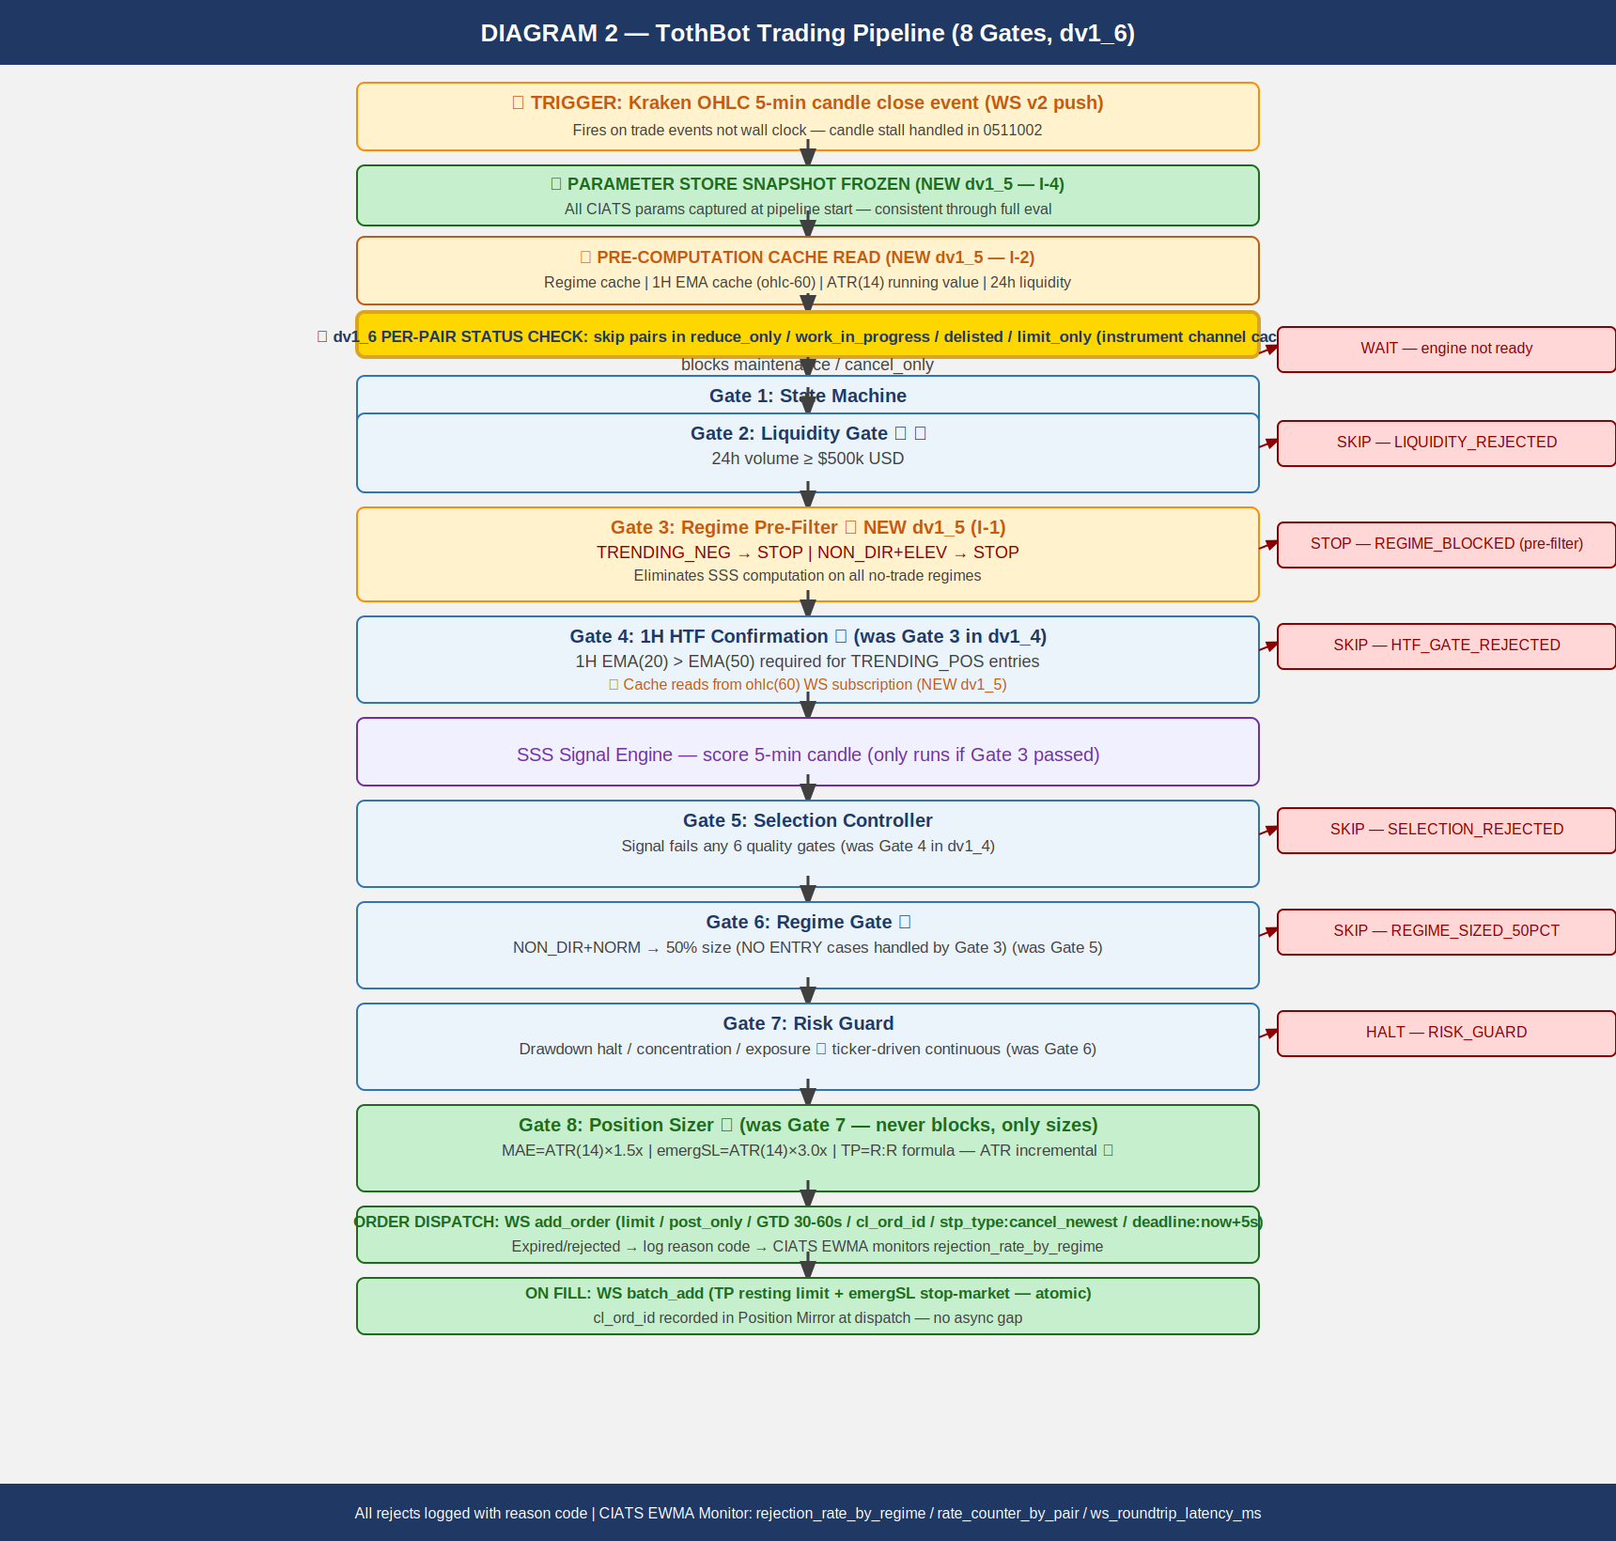

3.1 Gate Summary
PRE-STEP: Parameter Store Snapshot Frozen — all CIATS params captured as read-only. CIATS writes at inter-trade boundaries only.
PRE-STEP: Pre-Computation Cache Read — regime, 1H EMA, ATR(14), 24h liquidity, per-pair status. Zero computation on hot path.
★ Per-pair Instrument Status Check (dv1_6) — skip reduce_only/work_in_progress/delisted/limit_only pairs.
Gate 1: State Machine — maintenance or cancel_only: WAIT.
Gate 2: Liquidity Gate ★ — 24h volume < $500k USD: SKIP → LIQUIDITY_REJECTED.
Gate 3: Regime Pre-Filter ★ (I-1) — TRENDING_NEG (any vol) or NON_DIR+ELEVATED: STOP → REGIME_BLOCKED.
Gate 4: 1H HTF Confirmation ★ — 1H EMA(20) ≤ EMA(50) for TRENDING_POS: SKIP → HTF_GATE_REJECTED.
SSS Signal Engine — scores 5-min candle; only reached if Gate 3 passed.
Gate 5: Selection Controller — fails any of 6 quality gates: SKIP → SELECTION_REJECTED.
Gate 6: Regime Gate — NON_DIR+NORMAL: 50% position size only.
Gate 7: Risk Guard — drawdown/concentration/exposure. Ticker-driven continuous (I-7). HALT or continue.
Gate 8: Position Sizer — MAE=ATR×1.5x, emergSL=ATR×3.0x, TP=R:R formula. Validate qty_min + cost_min. Never blocks — only sizes.

ORDER DISPATCH: WS add_order (limit/post_only/GTD 30-60s/cl_ord_id/stp_type:cancel_newest/deadline:now+5s)
EXPIRED/REJECTED: log reason → CIATS EWMA rejection_rate_by_regime. Done.
ON FILL: WS batch_add (TP resting limit + emergSL stop-market ATOMIC / cl_ord_id / stp_type:cancel_newest / deadline:now+5s)
Position Mirror records at dispatch: symbol(key), entry_fill_price, qty, TP id, cl_ord_id, emergSL id.

4. Exit Architecture — Ground Zero Redesign for Kraken
Exit Controller owns all normal exits. Kraken off-book emergSL stop order is crash protection only. OTO evaluated and rejected (AR-008).

Diagram 3 — Exit Architecture: Ground Zero Redesign (dv1_6)
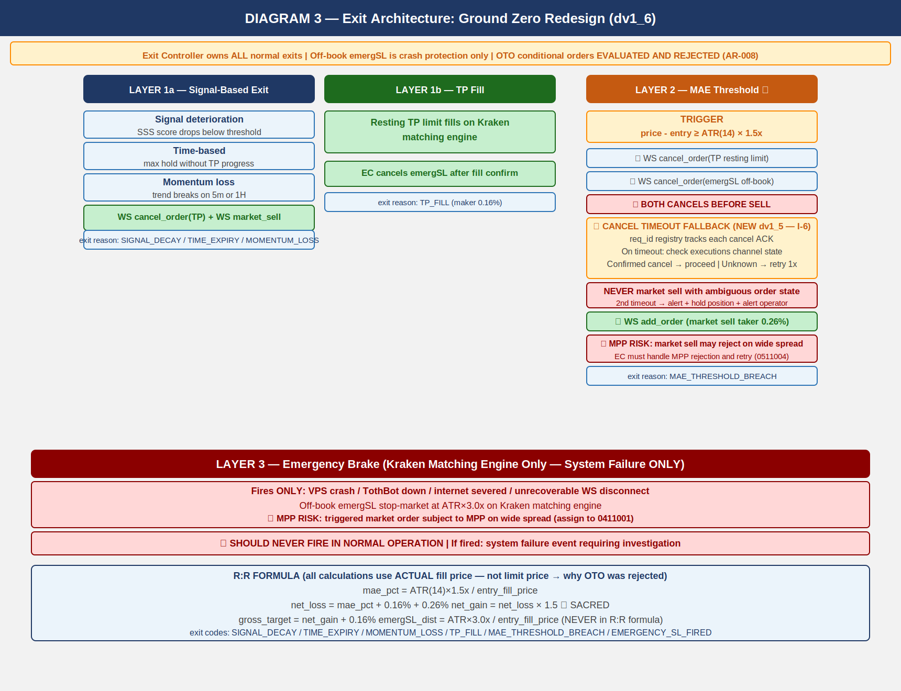

4.1 Three-Layer Summary
Layer 1a — Signal-Based Exit:
Signal decay / time expiry / momentum loss. WS cancel TP + market sell.
Exit reason: SIGNAL_DECAY / TIME_EXPIRY / MOMENTUM_LOSS

Layer 1b — TP Fill:
Resting TP limit fills on Kraken matching engine. EC cancels emergSL after fill confirm.
Exit reason: TP_FILL (maker 0.16%)

Layer 2 ★ — MAE Threshold:
Trigger: price - entry >= ATR(14) × 1.5x (bid price via bbo trigger ★ A-23)
SEQUENCE CRITICAL: (1) cancel TP → (2) cancel emergSL → THEN (3) market sell
Cancel timeout fallback: req_id registry tracks cancel ACKs. On timeout:
check executions channel. Confirmed cancelled: proceed. Unknown: retry once.
Second timeout: ALERT + hold position. NEVER market sell with ambiguous state.
MPP handling: on rejection, retry with IOC limit at best_bid - 0.2%.
Exit reason: MAE_THRESHOLD_BREACH

Layer 3 ★ — Emergency Brake (Crash Protection ONLY):
VPS/TothBot/internet failure only. Off-book emergSL stop-market at ATR×3.0x.
MUST NEVER FIRE IN NORMAL OPERATION. Subject to MPP.
Exit reason: EMERGENCY_SL_FIRED

4.2 R:R Formula (SACRED)
mae_pct = ATR(14) × 1.5x / entry_fill_price (ACTUAL fill price — not limit)
net_loss = mae_pct + 0.16% + 0.26% (entry maker + MAE taker exit)
net_gain = net_loss × 1.5 *** SACRED — HARDCODED ***
gross_target = net_gain + 0.16% (TP maker exit)
emergSL_dist = ATR(14) × 3.0x / entry_fill_price (NOT in R:R formula)
NOTE: All calculations use actual fill price — OTO uses limit price. This is why OTO was rejected (AR-008).

5. Regime Taxonomy
Six-regime grid is foundation of CIATS regime-segmented analysis. Every trade tagged with both asset_regime and market_regime (BTC proxy). Computed daily at 00:00 UTC.

Diagram 4 — Regime Taxonomy: 6-Regime Grid + Two-Level Tagging (dv1_6)
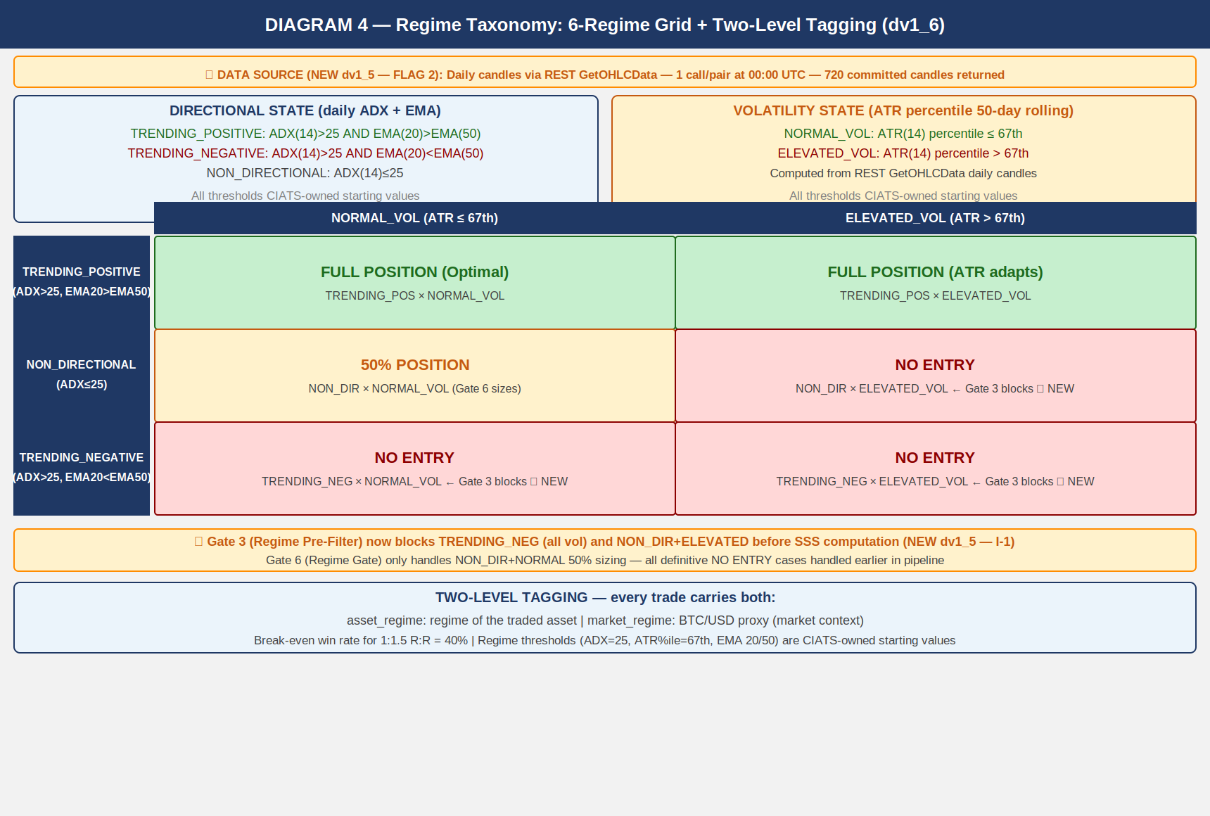

5.1 Computation
DATA SOURCE: Daily candles via REST GetOHLCData at 00:00 UTC.
720 entries returned. CRITICAL: exclude response[-1] always (uncommitted candle).
Use only response[:-1]. Stagger calls: asyncio.sleep(1.1) between pairs ★ A-24.

DIRECTIONAL STATE: ADX(14) + EMA(20) vs EMA(50) on committed daily candles
TRENDING_POSITIVE: ADX(14) > 25 AND EMA(20) > EMA(50)
TRENDING_NEGATIVE: ADX(14) > 25 AND EMA(20) < EMA(50)
NON_DIRECTIONAL: ADX(14) <= 25

VOLATILITY STATE: ATR(14) percentile rank in 50-day rolling window
NORMAL_VOL: ATR percentile <= 67th
ELEVATED_VOL: ATR percentile > 67th

ENTRY DECISIONS:
TRENDING_POS + NORMAL_VOL: FULL POSITION (optimal)
TRENDING_POS + ELEVATED_VOL: FULL POSITION (ATR adapts stop)
NON_DIR + NORMAL_VOL: 50% POSITION (Gate 6 sizing)
NON_DIR + ELEVATED_VOL: NO ENTRY (Gate 3 blocks) ★
TRENDING_NEG + NORMAL_VOL: NO ENTRY (Gate 3 blocks) ★
TRENDING_NEG + ELEVATED_VOL: NO ENTRY (Gate 3 blocks) ★

ALL REGIME THRESHOLDS ARE CIATS-OWNED STARTING VALUES. CIATS validates each after 600 closed trades.

6. CIATS Architecture and Data Flows
CIATS is fully asynchronous. Never blocks the trading critical path. Reads only from the Logger. Writes only to the Parameter Store. Deming PDCA governs every change.

Diagram 5 — CIATS Architecture: Data Flows and Improvement Cycle (dv1_6)
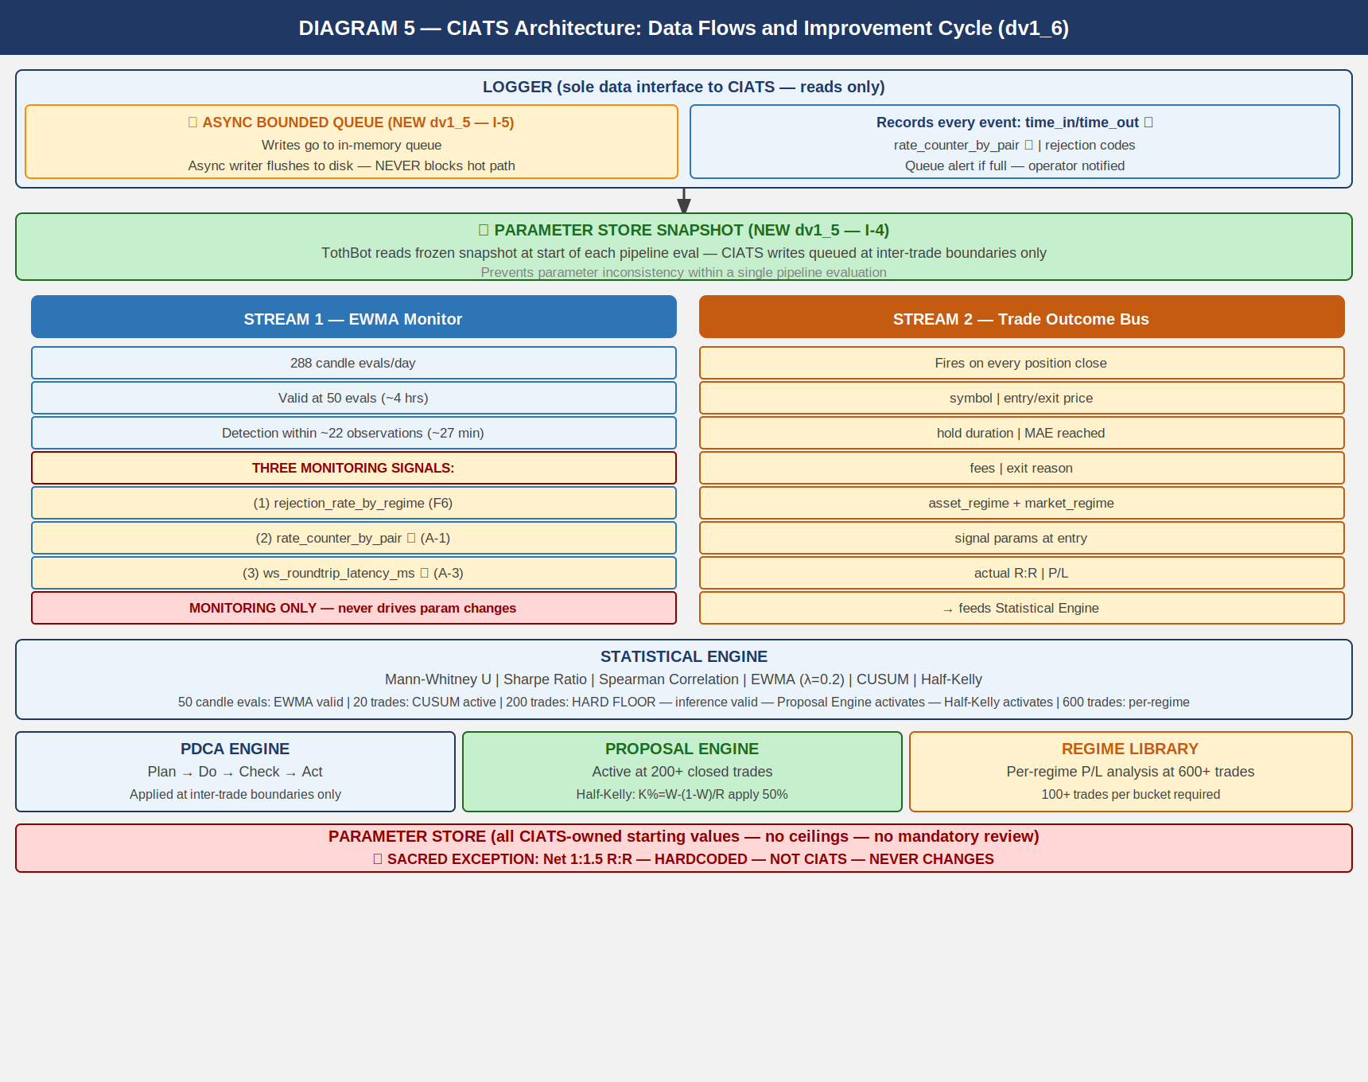

6.1 Two Data Streams
Stream 1: EWMA Monitor
288 candle evals/day. Valid at 50 evals (~4 hrs). lambda=0.2.
Three monitoring signals:
(1) rejection_rate_by_regime (F6)
(2) rate_counter_by_pair from executions channel (A-1)
(3) ws_roundtrip_latency_ms from WS response timestamps (A-3)
MONITORING SIGNALS ONLY — never drives parameter changes.

Stream 2: Trade Outcome Bus
Fires on each position close. Captures: symbol, entry/exit price, hold duration,
MAE reached, fees, exit reason, both regime tags, signal params at entry, actual R:R, P/L.

LOGGER — ASYNC BOUNDED QUEUE:
Queue size: 10,000 entries. Separate async writer flushes to disk.
Logger NEVER blocks the trading hot path.

PARAMETER STORE — SNAPSHOT PATTERN:
Frozen snapshot at start of each pipeline eval. CIATS writes at inter-trade boundaries.

6.2 Statistical Thresholds
50 candle evals: EWMA Monitor valid. Monitoring only.
200 trades HARD FLOOR: Inference valid. Proposal Engine activates. Half-Kelly activates.
SE(win_rate)~3.5%, SE(Sharpe)~7.2%.
600 trades: Per-regime analysis. 100+ per bucket. MW power ~85% at alpha=0.01.

Mann-Whitney alpha: 0.01 (one-sided). 99% confidence required.
Spearman rho: |rho| > 0.3 AND p < 0.05 (both conditions).
CUSUM parameters: k=0.5*sigma, h=4*sigma. Starting values.
PDCA minimum: Min 50 trades between any two parameter changes.

7. Complete System: One CIATS-Owned Organism
CIATS OWNS EVERYTHING EXCEPT 1:1.5 R:R: All parameters, thresholds, sizing decisions, halt thresholds, multipliers, and trading rules are CIATS-owned starting values.

Diagram 6 — Complete System: One CIATS-Owned Organism (dv1_10)
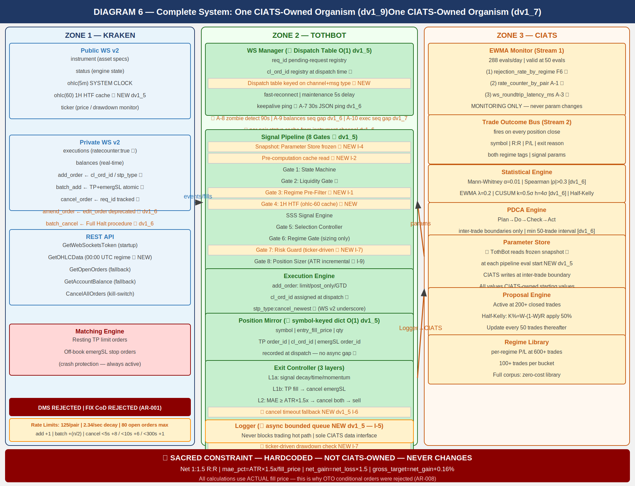

8. Locked Architectural Decisions
AR-001: No Dead Man Switch — crash protection is resting TP + emergSL on matching engine. DMS and FIX cancel-on-disconnect both REJECTED.
AR-002: Position Mirror — symbol-keyed dict, O(1) lookup.
AR-003: Restart reconciliation — PREFERRED: snap_orders:true. FALLBACK: REST.
AR-004: Two API key pairs — DATA + TRADE. Nonce window 10,000ms.
AR-005: WS v2 only. All future Kraken enhancements in v2 only.
AR-006: Entry order — limit/post_only/GTD/cl_ord_id/stp_type:cancel_newest/deadline:now+5s. ★ WS v2 uses underscores (cancel_newest). REST uses hyphens (cancel-newest). Never confuse.
AR-007: TP placement — resting limit via batch_add on fill. Actual fill price for R:R. batch_add includes deadline:now+5s and stp_type:cancel_newest.
AR-008: Emergency SL — stop-market via batch_add atomic with TP. ATR(14) x 3.0x. OTO REJECTED: uses limit price, violates R:R.
AR-009: Short deferred.
AR-010: 24/7/365. CIATS adds stand-down via PDCA if data supports.
AR-011: Net 1:1.5 R:R — SACRED — HARDCODED — NOT CIATS-OWNED.
AR-012: Fee baseline — Maker 0.16% / Taker 0.26%.
AR-013: Kraken Pro Intermediate tier confirmed.
AR-014: Logger async bounded queue (10,000 entries). Never blocks hot path.
AR-015: WS dispatch table O(1) routing on channel+message type.
AR-016: ATR(14) incremental running calculation. O(1) per update.
AR-017: Daily regime via REST GetOHLCData at 00:00 UTC. CRITICAL: exclude response[-1]. STAGGER 1.1s/pair.
AR-018: amend_order PRIMARY. edit_order DEPRECATED.
AR-019: batch_cancel for Full Halt multi-order cancellation.
AR-020: Per-pair instrument status cache from instrument channel.
AR-021: Executions channel sequence gap detection → REST GetOpenOrders reconciliation.
AR-022: cancel_reason field deprecated — use reason field in all executions channel parsing.
AR-023: Complete exec_type dispatch table required. All 10 values handled explicitly.
AR-024: restated exec_type = engine maintenance amend. Must not trigger Position Mirror update.
AR-025: All REST calls via aiohttp. asyncio TaskManager pattern mandatory. systemd WatchdogSec=120.
AR-026: order_status:true MANDATORY in executions subscription.
AR-027: interval_begin replaces deprecated timestamp in OHLC channel.
AR-028: price_increment replaces deprecated tick_size. qty_min and cost_min validated Gate 8.
AR-029: WS connect max_size=10MB + open_timeout=10 on all connections.
AR-030: maxratecount from executions subscription ACK is the operative rate counter ceiling.
AR-031: Subscription ACK warnings[] parsed and logged. QueryOrdersInfo for targeted reconciliation.
AR-032 ★ dv1_10: stp_type FORMAT CORRECTION — WS v2 underscores (cancel_newest). REST hyphens (cancel-newest). All WS v2 add_order and batch_add MUST use cancel_newest (underscore).
AR-033 ★ dv1_10: deadline parameter on all WS v2 add_order and batch_add. Standard: now+5s. Range 500ms–60s.
AR-034 ★ dv1_10: Ticker event_trigger:bbo for pairs WITH open positions; event_trigger:trades without. WS Manager manages per-pair trigger based on Position Mirror.
AR-035 ★ dv1_10: aiohttp ClientSession: ClientTimeout(total=10,connect=5,sock_read=8) + TCPConnector(limit=10,limit_per_host=5,force_close=False).
AR-036 ★ dv1_10: Regime Engine GetOHLCData stagger: asyncio.sleep(1.1) between pairs. 50 pairs = 55s. Required — public REST rate limit: 1 call/second per IP+pair.
AR-037 ★ dv1_10: DATA and TRADE API keys IP-whitelisted to VPS IP (87.99.141.44). Update on VPS migration.

9. Complete CIATS Parameter Registry
ALL PARAMETERS ARE CIATS-OWNED STARTING VALUES.
tradeable_pct: 50% of portfolio
per_trade_pct: 5% → Half-Kelly at 200 trades (update every 50 thereafter)
max_concurrent: 20 positions
mae_mult (ATR x): 1.5x ATR(14)
emergency_sl_mult: 3.0x ATR(14)
entry_timeout_sec: 30-60s GTD
full_halt_drawdown: 10% of portfolio
session_pause_drawdown: 5% of portfolio
signal_thresholds: SSS gates (derived)
adx_threshold: 25
atr_percentile_threshold: 67th
htf_ema_periods: 20/50 daily
min_volume_usd_daily: $500k USD
1:1.5 R:R net: HARDCODED — SACRED — NOT CIATS-OWNED

10. Six FP/DP Validated System Improvements
F1: 1H HTF Confirmation Gate — 15-20% higher win rates with daily+hourly filter (5 sources 2024-2025). 1H EMA(20)>EMA(50) required for TRENDING_POSITIVE entries.

F2: ATR Dynamic Stop Distances — +15% performance, -22% max drawdown vs fixed stops. MAE ATR(14)×1.5x. Emergency SL ATR(14)×3.0x.

F3: Regime Gate — accuracy drops 65%→45-50% in NON_DIRECTIONAL. Gate 3 blocks NON_DIR+ELEV and TRENDING_NEG. Gate 6 sizes NON_DIR+NORM at 50%.

F4: Minimum Liquidity Gate — $1M+/day minimum for clean execution. $500k starting. Protects post_only fills.

F5: CIATS Half-Kelly Pathway — 75% optimal growth at 50% less drawdown (MacLean-Thorp-Ziemba). Activates at 200 trades.

F6: post_only Rejection Monitoring — rejection rate = direct signal of entry placement quality. CIATS EWMA adds rejection_rate_by_regime stream.

11. Complete Trade Lifecycle — Narrative Reference

11.1 Normal Trade (Entry to TP or Exit Controller)
OHLC 5-min candle close fires on public WS v2
Parameter Store snapshot frozen — all CIATS params captured
Pre-computation cache read — regime, 1H EMA, ATR(14), 24h liquidity, per-pair status
★ Per-pair instrument status check — skip reduce_only/work_in_progress/delisted
Gate 1: State Machine — online or post_only: continue; else halt and wait
Gate 2: Liquidity Gate — 24h volume >= $500k: continue; else skip
Gate 3: Regime Pre-Filter — TRENDING_NEG or NON_DIR+ELEV: STOP; else continue
Gate 4: 1H HTF Gate — 1H EMA(20) > EMA(50) for TRENDING_POS: continue; else skip
Signal Engine: SSS score computed on 5-min candle
Gate 5: Selection Controller — 6-gate quality evaluation: pass or reject
Gate 6: Regime Gate — TRENDING_POS: proceed; NON_DIR+NORM: 50% size
Gate 7: Risk Guard — drawdown/concentration/exposure: pass or halt
Gate 8: Position Sizer — validate qty_min + cost_min; size position; compute R:R
Execution: WS add_order (limit/post_only/GTD/cl_ord_id/stp_type:cancel_newest/deadline:now+5s)
If expired/rejected: log reason → CIATS EWMA rejection rate. Done.
If filled: WS batch_add → TP (resting limit) + emergSL (stop-market) ATOMIC
cl_ord_id / stp_type:cancel_newest / deadline:now+5s on both legs
Position Mirror records at dispatch: symbol, entry_fill_price, qty, TP id, emergSL id
Ticker switches to event_trigger:bbo for this pair (faster adverse price detection ★ A-23)
Exit Controller monitors via ticker continuous drawdown check
TP fills: EC cancels emergSL. Logger records exit. CIATS Trade Outcome Bus fires.

11.2 Layer 2 MAE Exit (Adverse Price)
Exit Controller detects: current_bid - entry >= ATR(14) × 1.5x (bid via bbo trigger ★)
WS cancel_order: cancel TP resting order
WS cancel_order: cancel emergSL stop order (SEQUENCE CRITICAL: both cancels before sell)
Cancel timeout fallback: req_id registry tracks ACKs. Timeout: check executions state.
Confirmed cancelled: proceed. Unknown: retry once. Second timeout: ALERT + hold.
NEVER issue market sell with ambiguous order state.
WS add_order: market sell (taker 0.26%)
MPP handling: on rejection, retry with IOC limit at best_bid - 0.2%.
Logger: exit reason = MAE_THRESHOLD_BREACH. CIATS Trade Outcome Bus fires.

11.3 Emergency SL (Layer 3 — System Failure Only)
VPS crashes / TothBot dies / internet severs / unrecoverable WS disconnect
Kraken matching engine fires off-book emergSL stop-market at ATR×3.0x
On restart: reconciliation detects closed position → Logger: EMERGENCY_SL_FIRED
THIS IS A SYSTEM FAILURE EVENT. SHOULD NEVER FIRE IN NORMAL OPERATION.

12. Open Items — Require Specification Documents
OI-001: Signal generation (SSS) — FP/DP derivation required. Blocks 0811001, 0811002.
OI-002: Asset selection universe — Kraken USDT/USDC pairs.
OI-003: Exit Controller full specification — MPP IOC retry, cancel timeout, ticker drawdown, batch_cancel.
OI-004: Entry limit placement — evaluate bbo trigger, L2 book, L3 book.
OI-005: Selection Controller — 6-gate spec, per-pair status check required.
OI-006: CIATS specification — Mann-Whitney alpha=0.01, Spearman, CUSUM, PDCA 50-trade interval.
OI-007: AA=04 Exchange Interface formal document.
OI-008: All AA=10 coding specs. WD documents active: 0411001 dv1_3, 1011001 dv1_1, 1011002 dv1_3, 1011010 dv1_1, 1011012 dv1_1, 1011013 dv1_1.

13. Revision History
dv1_0 03-23-2026 Initial document.
dv1_1 03-23-2026 Added all six system flow diagrams.
dv1_2 03-24-2026 Six changes: C-1 emergSL, C-2 rate limits, C-3 OHLC stall, A-1/A-2/A-3.
dv1_3 03-24-2026 Rebuilt as correct .docx with all six diagrams embedded.
dv1_4 03-24-2026 Seven changes: C-1 MPP, A-1 AR-001, A-2 cl_ord_id, A-3 snap_orders, A-4 stp_type, A-5 reconnect, A-6 OTO rejected.
dv1_5 03-24-2026 Eleven changes: FLAG1 ohlc(60), FLAG2 GetOHLCData, I-1 Gate 3, I-2 cache, I-3 O(1), I-4 param snapshot, I-5 logger queue, I-6 cancel timeout, I-7 ticker drawdown, I-8 dispatch table, I-9 ATR incremental.
dv1_6 03-24-2026 Six changes: amend_order primary, rate table, A-7/A-8/A-9 WS ops, per-pair status, GetOHLCData response[-1], auth + CIATS thresholds.
dv1_7 03-25-2026 A-10 executions sequence gap detection. AR-021 added. GetOpenOrders active gap recovery.
dv1_8 03-25-2026 Eight changes: A-11 cancel_reason, A-12 exec_type enum, A-13 restated, A-14 auth confirmed, IMP-06/07/08. AR-022–025. 1011013 created.
dv1_9 03-25-2026 Six changes: A-15 order_status:true CRITICAL, A-16 interval_begin, A-17 price_increment + qty_min/cost_min, A-18 max_size=10MB, A-19 maxratecount. AR-026–031. 0411001 dv1_2. 1011002 dv1_2.
dv1_10 03-25-2026 Seven new findings from third 10-search FP/DP validation (TB00011). A-20 CRITICAL stp_type format correction — WS v2 underscores not hyphens; all prior specs wrong, corrected throughout. A-21 deadline parameter on all add_order/batch_add. A-22 aiohttp timeout+connector. A-23 ticker bbo for open positions. A-24 regime REST stagger 1.1s/pair. AR-032–037. IMP-16–19. 0411001 dv1_3. 1011001 dv1_1. 1011002 dv1_3. 1011012 dv1_1. 1011013 dv1_1.

